1. **INTRODUCTION**
   1. *overview*
      * *Description of the project*

Project Description:

* 1. Dream Homes Realty, a construction company, uses Zoho Books to track project expenses, manage subcontractor payments, and handle invoicing. They can generate estimates and invoices for clients, track job costing, and monitor the profitability of each project. Zoho Books provides them with financial insights to make informed decisions.
  2. **PURPOSE**

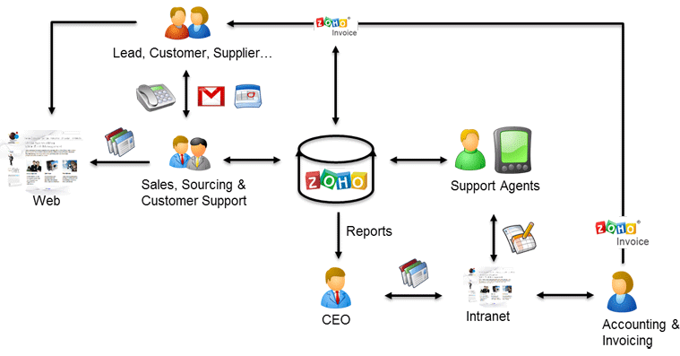

1. **Problem definition & design Thinking**
   1. *Empathy map*

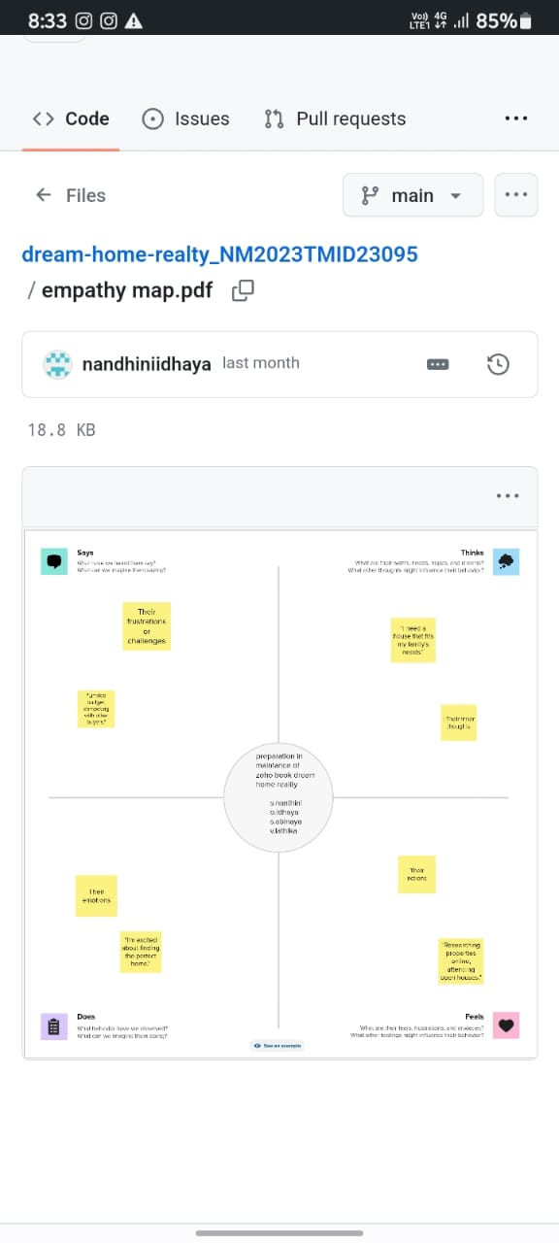

* 1. *Ideation & Brainstorming map*

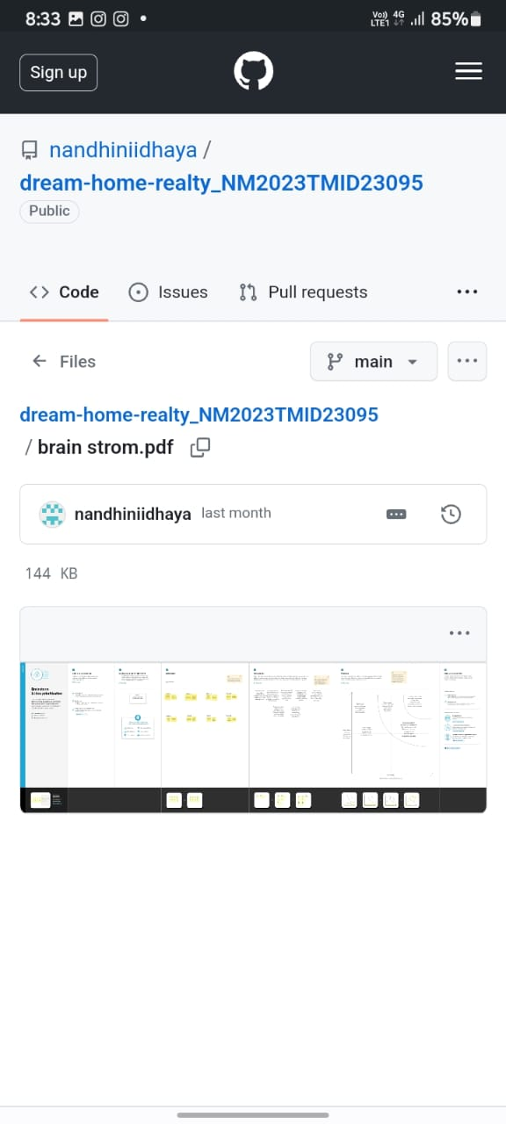

1. **Result Profit&loss**

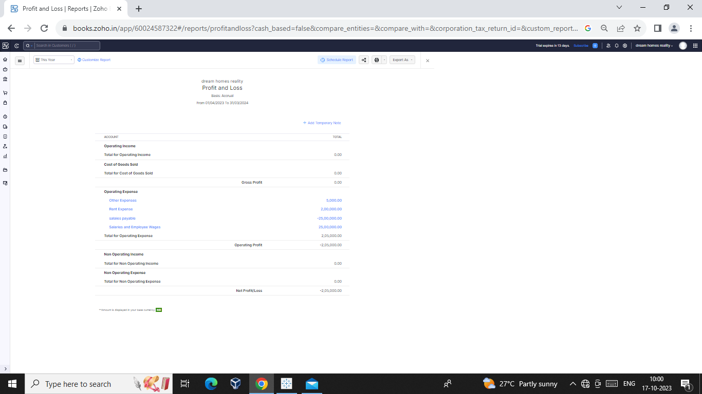

Balance sheet

:

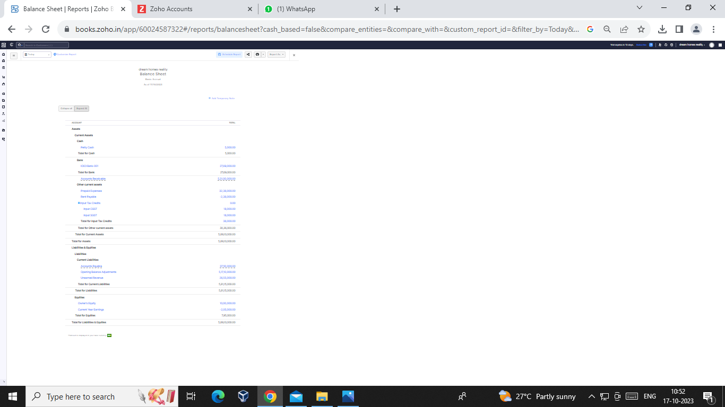

Purchase order

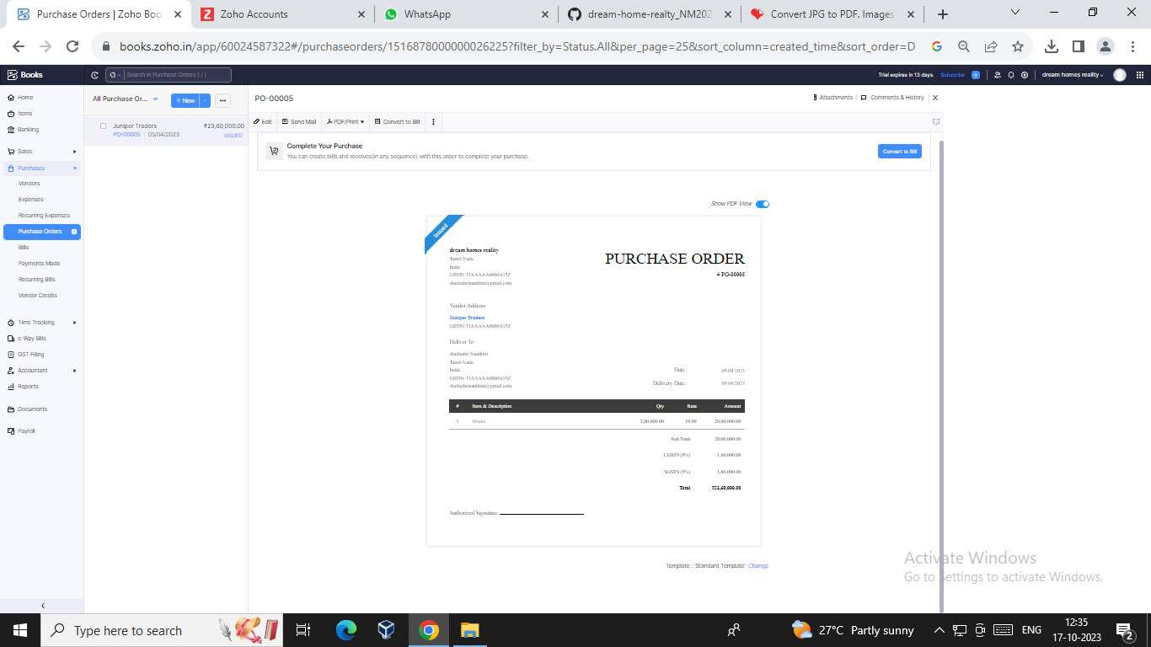

ADVANTANGES OF DREAM HOME REALTY:

Building a dream house allows you to create a home that is uniquely tailored to your individual needs and preferences.

You can choose everything from the layout and design to the materials and finishes, ens dream house is designed with your comfort in mind, taking into consideration everything from the placement of windows for natural light to the type of heating and cooling systems for optimal temperature control.

This can result in a more comfortable and enjoyable living environmenturing that your home is exactly the way you want it.

DISADVANTAGES OF DREAM HOME REALTY:

Huge brokerage amount. Less communication between the 2 parties. Less transparency.

1. *APPLICATIONS:*

DREAM HOME REALTY

1. **Conclusion:**

We need manual any recorded while the entering in this software. Then we can add the journal and then we can get the profit and loss account, balancesheet,GST, report and etc.

1. **FUTURE SCOPE:**

It maintain the accounts as well as the billing software is one software

It also help to reduce the work of the accountant to maintain accounts.

It gives less cost for maintain accounts.

APPENDIX

<https://github.com/nandhiniidhaya/dream-home-realty_NM2023TMID23095>

|  |
| --- |
|  |
| <!DOCTYPE html> |
|  | <html lang="en" data-color-mode="auto" data-light-theme="light" data-dark-theme="dark" data-a11y-animated-images="system" data-a11y-link-underlines="false"> |
|  |  |
|  | <style> |
|  | /* for each iteration, uncomment the CSS variable */ |
|  |  |
|  | /* light themes */ |
|  | [data-color-mode="light"][data-light-theme*="light"], |
|  | [data-color-mode="auto"][data-light-theme*="light"] { |
|  | /* iteration 1 */ |
|  | --border-color-iteration-1: #C8CCD0; |
|  | /* iteration 2 */ |
|  | --border-color-iteration-2: #BABFC5; |
|  | /* iteration 3 */ |
|  | --border-color-iteration-3: #A6ADB4; |
|  | /* iteration final */ |
|  | --border-color-iteration-4: #868F99; |
|  |  |
|  | /* the first value is the final step, which falls back to previous iterations */ |
|  | --control-borderColor-rest: var(--border-color-iteration-4, var(--border-color-iteration-3, var(--border-color-iteration-2, var(--border-color-iteration-1)))) !important; |
|  | } |
|  |  |
|  | /* dark themes */ |
|  | [data-color-mode="dark"][data-dark-theme*="dark"], |
|  | [data-color-mode="auto"][data-light-theme*="dark"] { |
|  | /* iteration 1 */ |
|  | --border-color-iteration-1: #363940; |
|  | /* iteration 2 */ |
|  | --border-color-iteration-2: #3F434B; |
|  | /* iteration 3 */ |
|  | --border-color-iteration-3: #4B5159; |
|  | /* iteration final */ |
|  | --border-color-iteration-4: #666E79; |
|  |  |
|  | /* the first value is the final step, which falls back to previous iterations */ |
|  | --control-borderColor-rest: var(--border-color-iteration-4, var(--border-color-iteration-3, var(--border-color-iteration-2, var(--border-color-iteration-1)))) !important; |
|  | } |
|  |  |
|  | [data-color-mode="dark"][data-dark-theme="dark_dimmed"], |
|  | [data-color-mode="dark"][data-dark-theme="light_high_contrast"], |
|  | [data-color-mode="dark"][data-dark-theme="dark_high_contrast"], |
|  | [data-color-mode="light"][data-light-theme="dark_dimmed"], |
|  | [data-color-mode="light"][data-light-theme="light_high_contrast"], |
|  | [data-color-mode="light"][data-light-theme="dark_high_contrast"] { |
|  | /* skip these themes, use the fallback */ |
|  | --control-borderColor-rest: initial !important; |
|  | } |
|  |  |
|  | @media (prefers-color-scheme: dark) { |
|  | /* dark colors in dark mode */ |
|  | [data-color-mode="auto"][data-dark-theme*="dark"] { |
|  | /* iteration 1 */ |
|  | --border-color-iteration-1: #363940; |
|  | /* iteration 2 */ |
|  | --border-color-iteration-2: #3F434B; |
|  | /* iteration 3 */ |
|  | --border-color-iteration-3: #4B5159; |
|  | /* iteration final */ |
|  | --border-color-iteration-4: #666E79; |
|  |  |